* Module : 1 (SDLC)

**Q.1 What is software ? What is software Engineering?**

Ans🡪 The things or Program that we can not touch Physically is called software .E.g. Notepad , VLC Media , etc.

🡪Software Engineering is the branch of computer science that deals with design, development, testing, and Maintain of software applications.

**Q.2 Explain types of software :-**

Ans.

🡪1. Application software – MS office, Paint, etc.

2. System software – Notepad, Calculator, etc.

3. Driver software – Audio driver, Video driver, etc.

4. Middleware – Database middleware, Server middleware, etc.

5. Programming software – Dev, C++, VS code, Turbo C, Eclipse, Clion,

**Q.3 What is SDLC? Explain each phase of SDLC**

Ans.

🡪SDLC:- Software Development Life Cycle

🡪There are 6 Phases of SDLC

1. Requirement Gathering – To gather all Requirement
2. Analysis- Analysis of all Requirements
3. Designing- Frontend Part (HTML, CSS, Java Script, ReactJS, etc.)
4. Coding or Implementation- Backend Part (Python, Java, PHP, .Net)
5. Testing- To test the website or software
6. Maintenance- To maintain the website or software.

**Q.4 What is DFD? Create a DFD Diagram on Flipkart**

Ans. It is a way to representing the data in a flow.

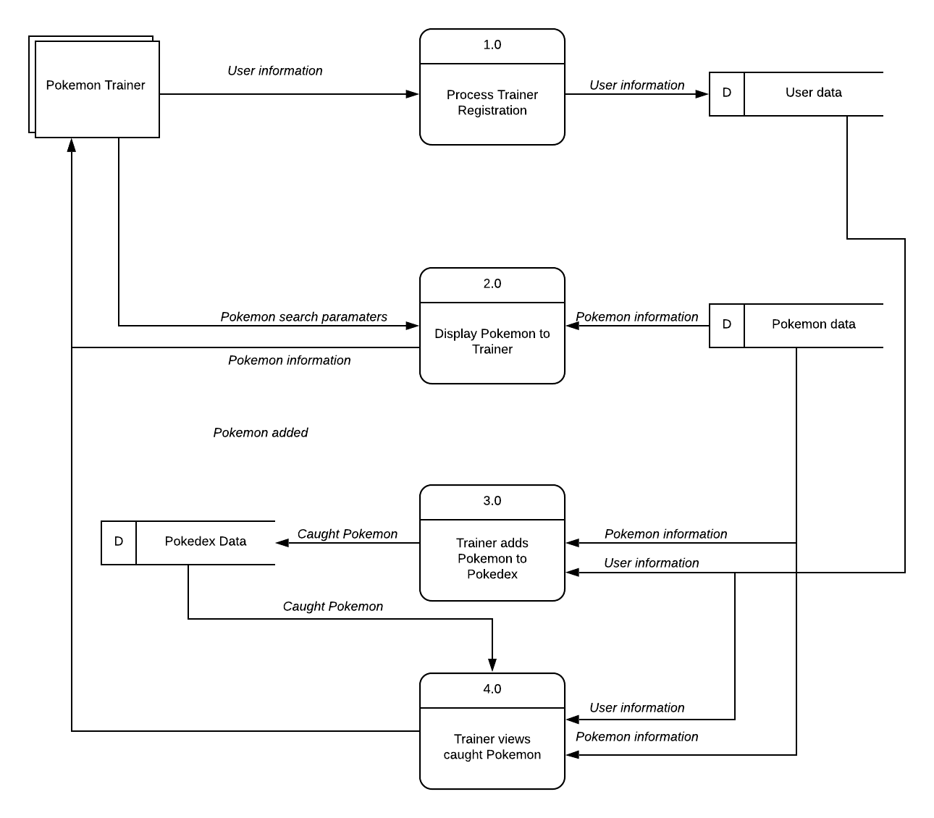

**Q.5** **What is flowchart? Create a flowchart to make addition of two numbers.**

Ans. By using flowchart we can understand the flow of our coder program.  
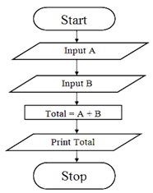

Q.6 What is use case Diagram? Create a use -case on bill payment on Paytm.

Ans. Use-case diagrams describe the high-level functions and scope of a system.

